Name | Loukik Tayshete
UID no. | 2021700065
Experiment No. | 6

AIM: | Implementation of Single Source Shortest path-Dijkstra's Algorithm
Program 1
PROBLEM STATEMENT : | Implementation of Single Source Shortest path-Dijkstra's Algorithm
ALGORITHM/  THEORY: | - Mark the source node with a current distance of 0 and the rest with infinity.  - Set the non-visited node with the smallest current distance as the current node, lets say C.  - For each neighbour N of the current node C: add the current distance of C with the weight of the edge connecting C-N. If it is smaller than the current distance of N, set it as the new current distance of N.  - Mark the current node C as visited.  - Go to step 2 if there are any nodes are unvisited.  function dijkstra(G, S)  for each vertex V in G  distance[V] <- infinite  previous[V] <- NULL  If V != S, add V to Priority Queue Q  distance[S] <- 0  while Q IS NOT EMPTY  U <- Extract MIN from Q  for each unvisited neighbour V of U  tempDistance <- distance[U] + edge_weight(U, V)  if tempDistance < distance[V]  distance[V] <- tempDistance  previous[V] <- U  return distance[], previous[]
PROGRAM: | #include<stdio.h>  #include<conio.h>  #define INFINITY 9999  #define MAX 10  void dijkstra(int G[MAX][MAX],int n,int startnode);  int main()  {  int G[MAX][MAX],i,j,n,u;  printf("Enter no. of vertices:");  scanf("%d",&n);  printf("\nEnter the adjacency matrix:\n");  for(i=0;i<n;i++)  for(j=0;j<n;j++)  scanf("%d",&G[i][j]);  printf("\nEnter the starting node:");  scanf("%d",&u);  dijkstra(G,n,u);  return 0;  }  void dijkstra(int G[MAX][MAX],int n,int startnode)  {  int cost[MAX][MAX],distance[MAX],pred[MAX];  int visited[MAX],count,mindistance,nextnode,i,j;  //pred[] stores the predecessor of each node  //count gives the number of nodes seen so far  //create the cost matrix  for(i=0;i<n;i++)  for(j=0;j<n;j++)  if(G[i][j]==0)  cost[i][j]=INFINITY;  else  cost[i][j]=G[i][j];  //initialize pred[],distance[] and visited[]  for(i=0;i<n;i++)  {  distance[i]=cost[startnode][i];  pred[i]=startnode;  visited[i]=0;  }  distance[startnode]=0;  visited[startnode]=1;  count=1;  while(count<n-1)  {  mindistance=INFINITY;  //nextnode gives the node at minimum distance  for(i=0;i<n;i++)  if(distance[i]<mindistance&&!visited[i])  {  mindistance=distance[i];  nextnode=i;  }  //check if a better path exists through nextnode  visited[nextnode]=1;  for(i=0;i<n;i++)  if(!visited[i])  if(mindistance+cost[nextnode][i]<distance[i])  {  distance[i]=mindistance+cost[nextnode][i];  pred[i]=nextnode;  }  count++;  }  //print the path and distance of each node  for(i=0;i<n;i++)  if(i!=startnode)  {  printf("\nDistance of node%d=%d",i,distance[i]);  printf("\nPath=%d",i);  j=i;  do  {  j=pred[j];  printf("<-%d",j);  }while(j!=startnode);  }  }
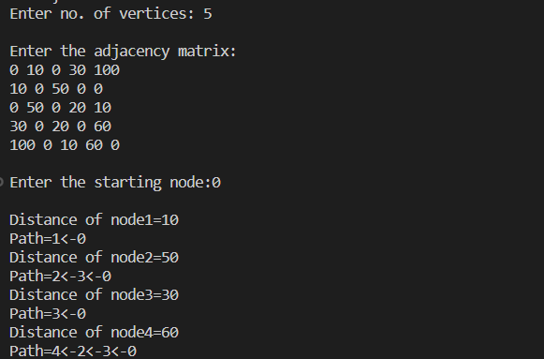
RESULT:
CONCLUSION: | Successfully implemented and learned Single Source Shortest path-Dijkstra's Algorithm

